E-mail to Families
Suggested Copy

Subject: Class of 2024 College Planning Virtual Event – Monday, September 18

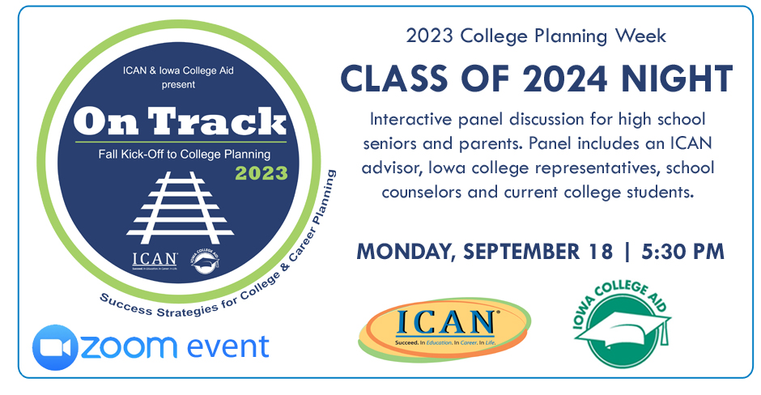

Please plan to attend the On Track Class of 2024 event on Sept. 18. On Track is a virtual event series hosting interactive panel discussions for students and parents by grade-level, so you get only the information you need for your current planning needs.

The panel consists of planning experts, Iowa college representatives, and school counselors. Joining the panel will also be current college students to share their experiences and advice with today’s high school students.

The senior event will focus on the senior year timeline, a financial aid overview, applications, scholarships, and action steps you can take now to help prepare you for college admissions. Bring your questions and join us.
On Track - Class of 2024 Virtual Event
Monday, September 18, 2023
5:30 – 6:30pm
Register: https://us06web.zoom.us/webinar/register/WN_e0cUDx8NQJirXAtI2NUq2Q#/registration
The event is FREE. Visit www.icansucceed.org/ontrack for all the event details and to register to attend.

